1. Run nslookup to obtain the IP address of a Web server in Asia. What is the IP address of that server?  
   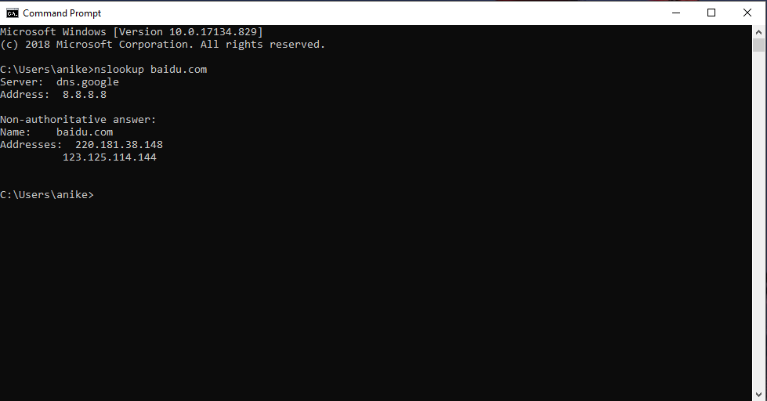  
     
   **The IP address of baidu.com’s server is 220.181.38.148.**
2. Run nslookup to determine the authoritative DNS servers for a university in Europe.  
   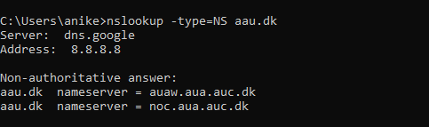
3. Run nslookup so that one of the DNS servers obtained in Question 2 is queried for the mail servers for Yahoo! mail. What is its IP address?  
   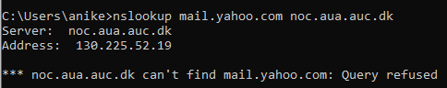  
   **The IP address is 130.225.52.19**

Part 2

1. Locate the DNS query and response messages. Are they sent over UDP or TCP?  
   **a) Query: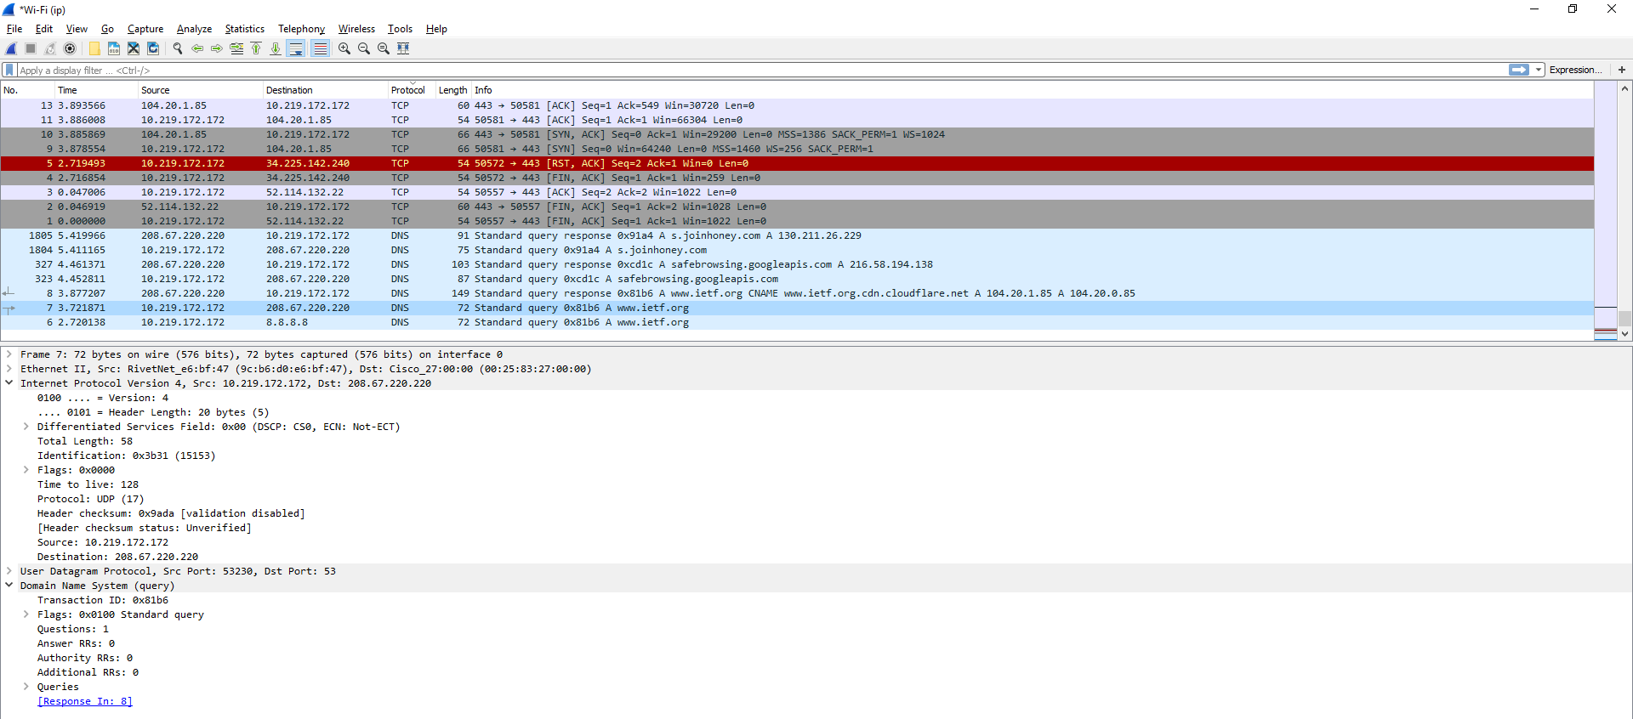 b) Response: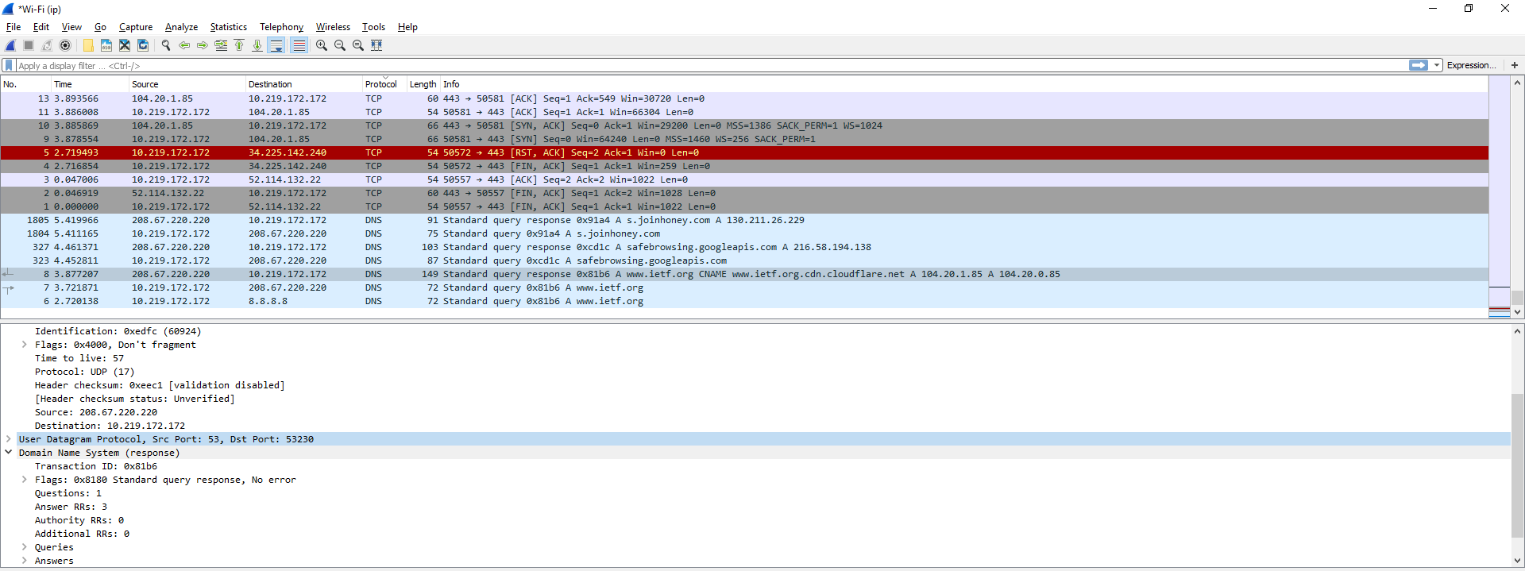 They are sent over UDP.**
2. What is the destination port for the DNS query message? What is the source port of DNS response message?  
   **The destination port for DNS query is 53 and the source port of DNS response is 53.**
3. To what IP address is the DNS query message sent? Use ipconfig to determine the IP address of your local DNS server. Are these two IP addresses the same?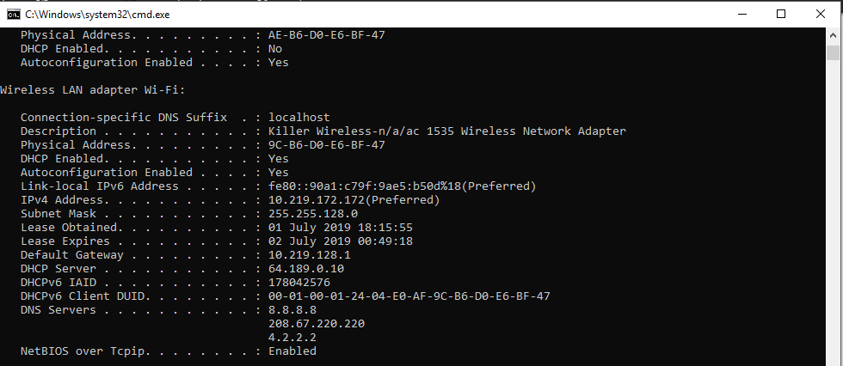  
   **It’s sent to 208.67.220.220, which is same as one of my DNS servers.**
4. Examine the DNS query message. What “Type” of DNS query is it? Does the query message contain any “answers”?  
   **It is a type A Standard Query and it does not contain any answers.**
5. Examine the DNS response message. How many “answers” are provided? What do each of these answers contain?  
   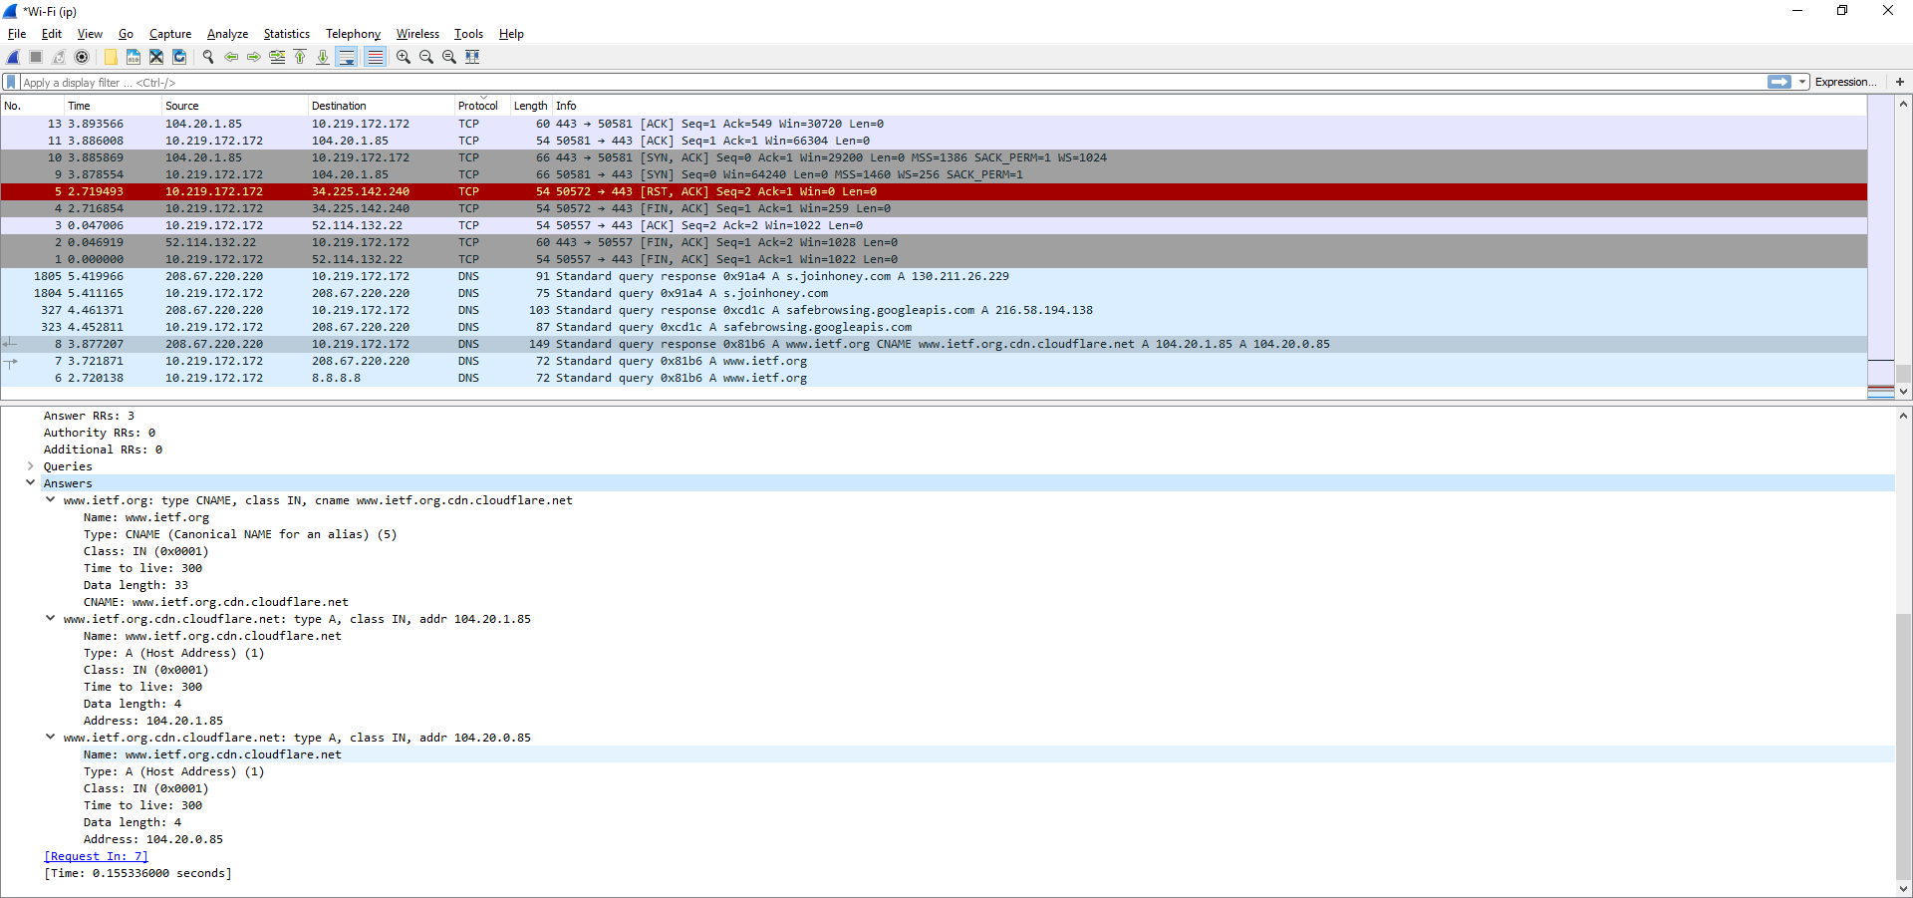  
   **There were 3 answers containing information about the name of the host, type of address, class, the Time To Live (TTL), the data length and the IP.**
6. Consider the subsequent TCP SYN packet sent by your host. Does the destination IP address of the SYN packet correspond to any of the IP addresses provided in the DNS response message?  
   **The TCP SYN packet was sent to 104.20.1.85 which corresponds to the IP address provided in the DNS response message.**
7. This web page contains images. Before retrieving each image, does your host issue new DNS queries?  
   **No.**

Part 3

1. What is the destination port for the DNS query message? What is the source port of DNS response message?  
   a) Query  
   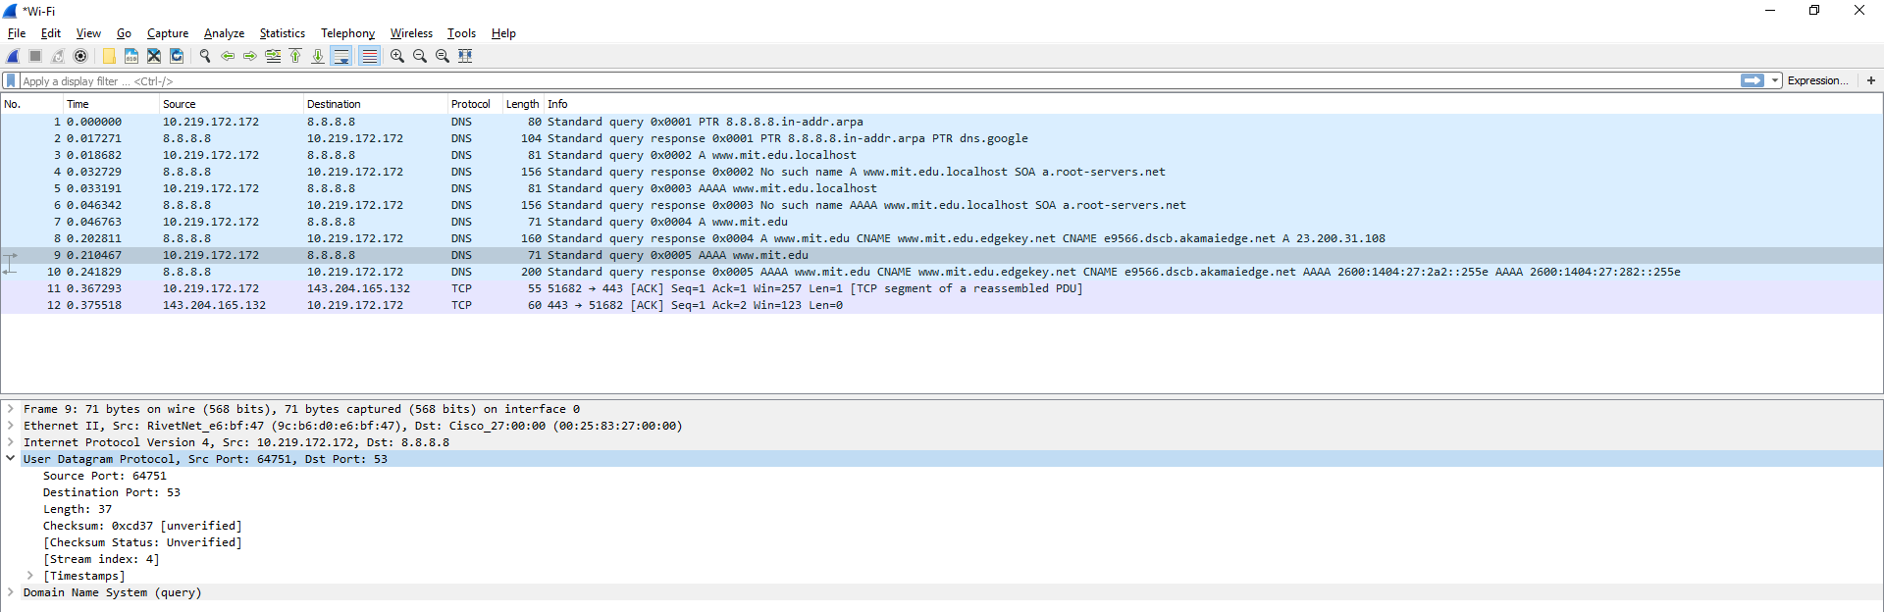  
   b) Response  
   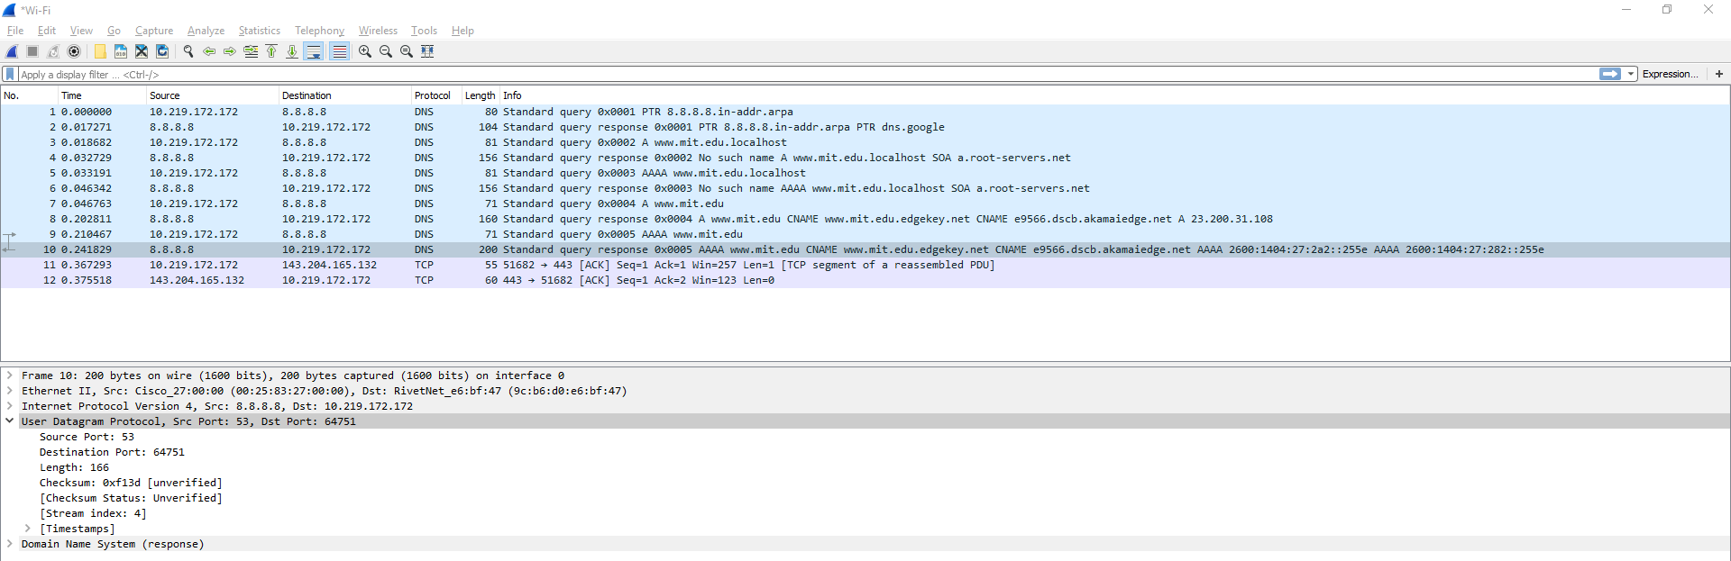  
   **The destination port for DNS query is 53 and the source port of DNS response is 53.**
2. To what IP address is the DNS query message sent? Is this the IP address of your default local DNS server?  
   **It’s sent to 8.8.8.8, which is same as one of my DNS servers.**
3. Examine the DNS query message. What “Type” of DNS query is it? Does the query message contain any “answers”?  
   **The query is of type A and it does not contain any answers.**
4. Examine the DNS response message. How many “answers” are provided? What do each of these answers contain?  
   **There were 3 answers containing information about the name of the host, type of address, class, the Time To Live (TTL), the data length and the IP.**
5. Provide a Screenshot  
   